VIETNAMNATIONALUNIVERSITY–HCM

**INTERNATIONALUNIVERSITY**



**Web Application Development Project**

#### Topic: Online CV builder

**Advisor: Dr. Nguyen Van Sinh**

A report submitted to the School of Computer Science and Engineering

in partial fulfillment of the requirements for the Final Project

in Web Application Development course

#### Group

|  |  |  |  |
| --- | --- | --- | --- |
| **No.** | **Name** | **StudentID** | **Contribution** |
| **1** | **Phạm Đăng Quang** | **ITCSIU21147** | **25%** |
| **2** | **Đỗ Tấn Lộc** | **ITCSIU21199** | **25%** |
| **3** | **Đặng Đình Nguyên** | **ITITIU20133** | **25%** |
| **4** | **Phạm Quốc Huy** | **ITITIU21215** | **25%** |

**Table of Contents**

**I. INTRODUCTION----------------------------------------------------------------------------page 3**

**I.1. Project Information----------------------------------------------------------------------------page 3**

**I.2. Work Breakdown Structure----------------------------------------------------------------------------page 3**

**I.3. Development Process----------------------------------------------------------------------------page 4**

**I.4. Development Environment----------------------------------------------------------------------------page 5**

**II. REQUIREMENT ANALYSIS AND DESIGN---------------------------------------------page 6**

**II.1. Requirement Analysis ----------------------------------------------------------page 6**

**II.1.a. Use Case Diagram----------------------------------------------------------------------------page 6**

**II.1.b. Functional Requirements----------------------------------------------------------------------------page 14**

**II.1.c. Non-Functional Requirements ----------------------------------------------------------------------------page 15**

**II.2. Design -------------------------------------------------------------------------------page 16**

**II.2.a. API diagram----------------------------------------------------------------------------page 16**

**II.2.b. ERD diagram----------------------------------------------------------------------------page 17**

**II.2.c. Sequence Diagram----------------------------------------------------------------------------page 17**

**II.2.d. Class Diagram----------------------------------------------------------------------------page 20**

**III. IMPLEMENTATION ----------------------------------------------------------------------page 20**

**III.1. Login-Signup-Forgot Password----------------------------------------------------------------------------page 20**

**III.2. Create CV----------------------------------------------------------------------------page 27**

**III.3. Save/Download CV----------------------------------------------------------------------------page 30**

**III.4. Search CV----------------------------------------------------------------------------page 32**

**IV. Discussion and Conclusion----------------------------------------------------------------------------page 33**

**V. References----------------------------------------------------------------------------page 34**

# I.Introduction

These days, job seekers frequently use online CV generator since they make it simple and quick to build a professional resume. These websites help users make their resumes stand out from the competition by offering a range of CV generation, customisation, and improvement choices. THis project study aims to gather more data about online CV builders, their uses, and their consequences for software engineers.

## Project Information

In the background, the primary objective of the project is to develop a website that makes it simple for users to produce, modify, and update resumes. This website is helpful since businesses prefer to view digital resumes and job seekers want to showcase their accomplishments and abilities in a distinctive and professional way. Second, the project aims to create a functioning, user-friendly website that can be tailored to suit different requirements. A broad spectrum of software engineering skills, such as problem-solving, system design, coding, testing, and result validation, will be required for this project. Ultimately, the goal is to create a website that satisfies users and adheres to the highest software design and development standards

1. **Work Breakdown Structure**

The structure of our project can be expressed in the ***Figure 2.1:***

*Figure 1.2.1 Work Breakdown Structure*

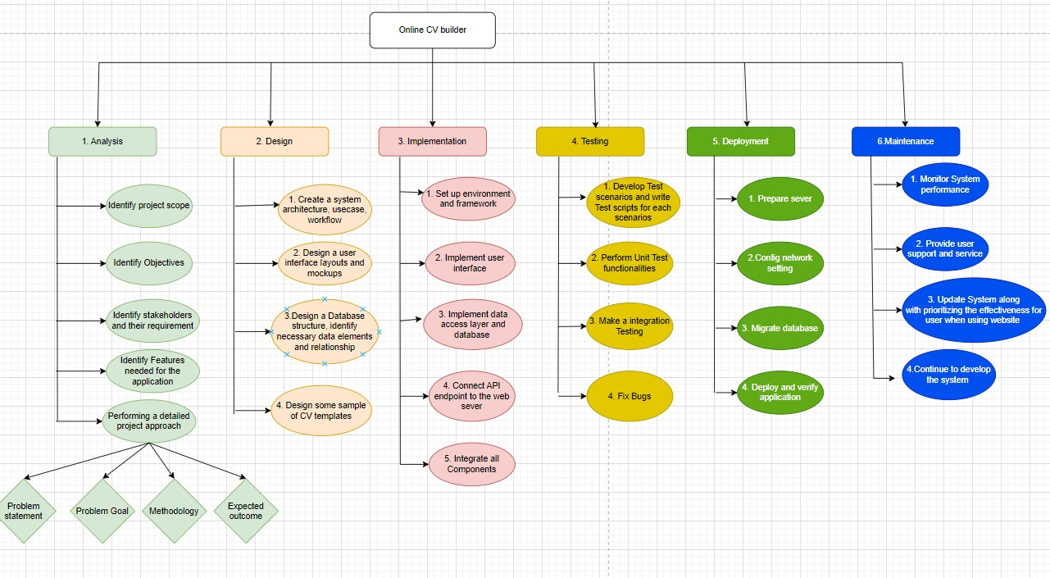

Based on the work breakdown structure, our online CV builder project may be divided into six stages: analysis, design, implementation, testing, deployment, and maintenance:

* **Analysis**: Establishing the project's goals and scope, stakeholders' needs, and the online CV generator's features are all part of the analytical process. Because it is used to understand the direction of the project and the expectations of the stakeholders, the analysis is essential and needs to be completed at the very beginning.
* **Design**: By examining the system architecture, which comprises use cases and sequence diagrams, we may determine whether or not the design has been created during the design process. During the design phase, the necessary data pieces and links are specified, along with sample CV templates, and mockups of the user interface and database structure are also constructed. These components help to guarantee that the system satisfies the requirements of the stakeholders and act as a visual reference for the development team.   
  Implementation: Configuring the framework and development environment is part of the implementation stage. This step will primarily focus on developing the database, data access layer, and user interface.Regarding the APIs, which are connected to the web server, every part is combined to create a complete system. Additionally, the concept is transformed into a working software program at this point.
* **Testing:** To find out how the system functions and how its components interact, testing involves creating testing scenarios and conducting tests. A closer examination reveals that these tests confirm that everything functions as it should and that the system operates as planned. Furthermore, any issues or flaws discovered at this point will be tested and rectified before the system is made functional.
* **Deployment**: This stage involved setting up the network, moving the database, setting up the server, and turning on the program.We have to make sure the program works as intended in the production setting throughout this phase. This phase, in summary, shows how the project moves from development to end-user deployment.
* **Maintainence**: During the maintenance phase, the system is updated, user support and service are provided, and system performance is monitored. The website's usability is given top priority, and the system is updated frequently to accommodate evolving user demands and technical developments.

1. **Development Process**

## System's Workflow

The steps in the system workflow are as follows:   
+, The user will be on the home page at first. Now, the user has three choices: create their CV, look for CV templates, and log in or register. The system will continue to function as a Guest if users would rather Search CV and Create a CV without logging in or registering.

+, The Search CV Template option enables the user to utilize the engine toolbar to search for the CV they desire. The toolbar's purpose is to filter the user's entered keywords and display CV templates that match their keyword requirement. They can change the CV and save it to their shop after choosing a template (the system will ask them to log in to their account first).

+, In the “Get Started” option, the system takes the user to a website where they can fill in the blanks in the CV template requirements which they can still process as a Guest. Once the user has completed filling out the CV up to the final stage, they may evaluate the CV they just made. The user may update the resume, store it in their account, and download it after they have finished checking in and paying the download charge.

+, In the “CV stored” option: It requires the user to have an account and login first, then it will move the user to their account storage where they can find their Saved CV. The saved CV can be modified or used again by the user before downloading.

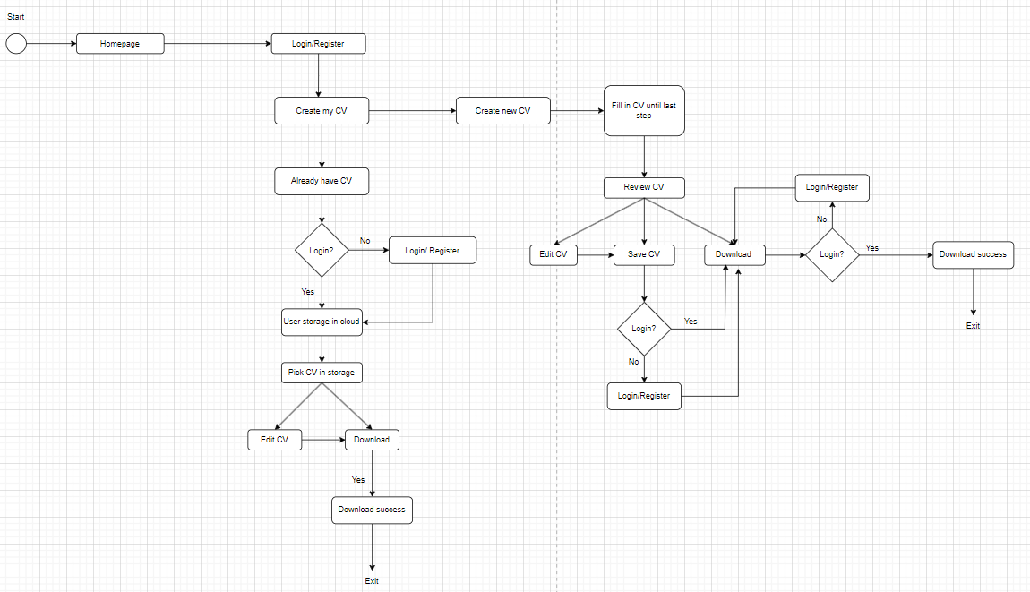

*Figure 1.3.2 System Workflow*

1. **Development Environment**

Our project software is built applying the following technologies:

As for Front-end:

* **HTML**: We implemented HTML for structuring the content of the web pages such asheadings, paragraphs, images, etc. It also makes the elements of the website to be more arranged
* **CSS**: We implemented CSS for styling and layout of the web pages, such as colors, fonts, margins, padding, borders, etc. It applies rules to the html element to control their appearance and positions.
* **Javascript:** We’ve used JavaScipts to make our web pages interactive, responding touser events, changing HTML elements, and making backend calls. Moreover, We’ve also used libraries and frameworks to enhance its functionality and simplify our code.
* **Figma:** Initially,we intended to use Figma as website to design our images and export CSS and HTML code. However, we found that the code did not meet our requirements and had some font and text bugs when running, so we only used it code as a reference when creating CV templates.

As for Back-end:

* We use **API** (application programming interface) to set up a connection between clients and server to communicate for response and request (as json file) to get, post, update, delete data
* Framework **Spring boot** for:

+ Rapid development (auto-configuration, embedded servers)

+ RESTful Web Services (@RestController annotation and HTTP methods (GET, POST, PUT, DELETE)

+ Dependency Management (starter web, data jpa, lombok, mysql,...)

+ Database integration (easy integration using spring data jpa/jdbc via resources/application.properties)

+ Testing (starter test to boot, test for database access,...)

**II. Requirement Analysis and Design**

1. **Requirement Analysis**
2. **Use case Diagrams**

**Use case Diagram for the whole software:**

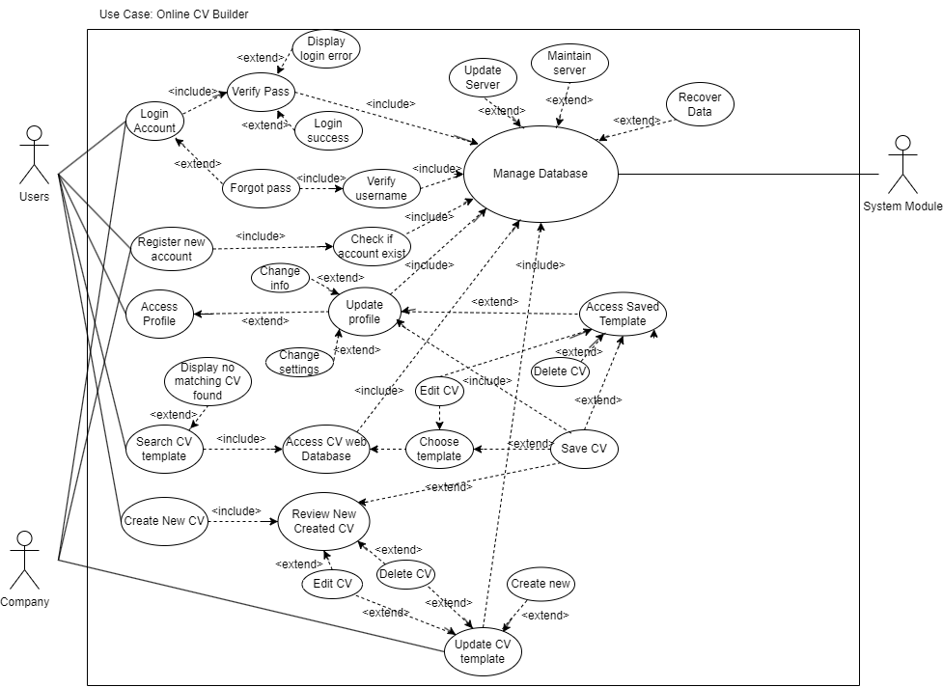

*Figure 2.1.1: Use Case Overall System*

### Use Case Login, Register, Forgot password

* **User Story:** After accessing the website homepage, Users have to input their username and password to the Login screen(which is also applied to the Systemmanagerandcompany). In the User and Company Case, If they are new to the website, they must Register a new account before accessing the software. After the Userfinishes creating a CV choose the CV template to save and successfully download. Then they can now logout the website. If the User Forgot the password, the system gives them a way to get their password back.

###### Use case diagram:

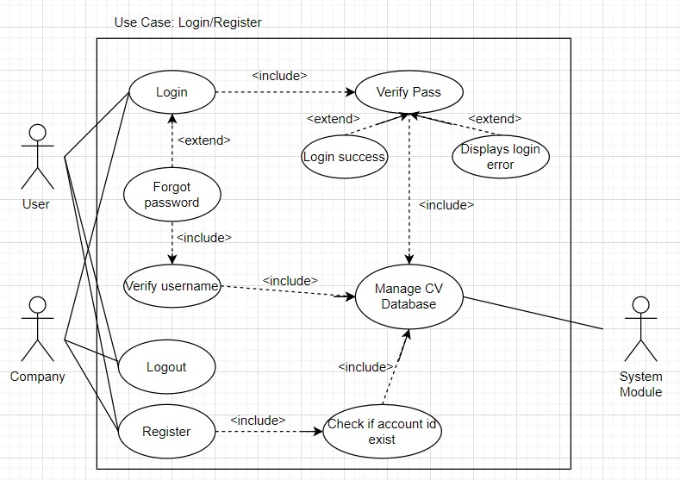

*Figure 2.1.2: Use Case Login/Register*

###### Use case using a table format:

***Table 1: Use Case table for Login/Registration***

|  |  |  |  |
| --- | --- | --- | --- |
| Use case name: | Use Case Login/Register | | |
| Created by: | Pham Dang Quang | Last updated by: | Pham Dang Quang |
| Date created: | 13/10/2024 | Date last updated: | 15/10/2024 |
| Actors: | Users, Company | | |
| Description: | Users create an account; login to the existing account or create a new password | | |
| Preconditions: | * User access to the software * User needs to have Internet | | |
| Postconditions: | * Always update the company template | | |

|  |  |
| --- | --- |
| Normal Flows: | 1. User login to an already existing account by verifying the password. 2. User logs into an already existing account. 3. The user creates a new account and checks the account ID. 4. The System Module manages the CV database. |
| AlternativeFlows: | * 1. Verify the account.   1.2 Login success.  1.3 Display there is an error when logging in or the wrong password.  1.4 The account exists and the User forgot the password, Recipating a new password needs to verify the info of the account and access to the database. |

### Use Case Search CV Templates

* **User Story**: The Users are allowed to use the search engine without login to look for CV templates after visiting the homepage of the website. On the search engine, Theuser has to input certain keywords into the search engine,the system now scans for matching keywords on the CV template and moves Users to the Search Results page. On the Search Result page, If the system finds a matching CVs keyword, it will display CV Templates that meet the user's needs. Otherwise, will display nothing. Whenever users find the template they want, they can edit it, save it to their account storage, and download it.

#### Use case diagram:

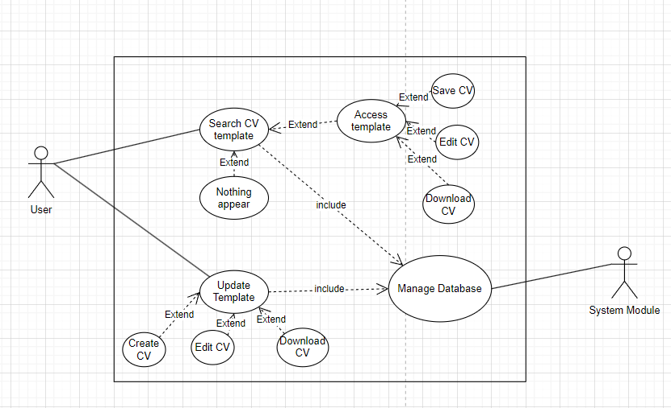

*Figure 2.1.3: Use Case Search CV templates*

###### Use case using a table format:

***Table 2: Use Case Table for Search CV format***

|  |  |  |  |
| --- | --- | --- | --- |
| Createdby: | Pham Dang Quang | Last updated by: | Pham Dang Quang |
| Date created: | 13/10/2024 | Date last updated: | 15/10/2024 |
| Actors: | Users, SystemModule | | |
| Description: | Users can access the software to create and edit CVs by using the template. | | |
| Preconditions: | * User access to the software * User needs to have Internet * User needs to choose the requirements template | | |
| Postconditions: | * Always update the template | | |
| Normal Flows: | 1. The admin updated the template to the manage CV database. 2. The System Module manages the CV database. 3. Users search the template | | |
| Alternative Flows: | * 1. The Admin created the CV template.   2. The Admin edited the CV template.   3. The Admin deleted the CV template.   1.4 Users find the template and access thetemplate.  1.5 Users save the CV.  1.6 Users edit the CV. | | |
| Exceptions: |  | | |
| Note and issues: |  | | |

### Use Case Create My CV and Access User Profile

* **User Story:** After accessing the website homepage, the User is allowed to press Get Started. The User chooses the first option Create New CV, they can freely fill in their CV information to the final step, which allows them to edit, save, and download (The user must log in to their account first to process this step)

#### Use case diagram:

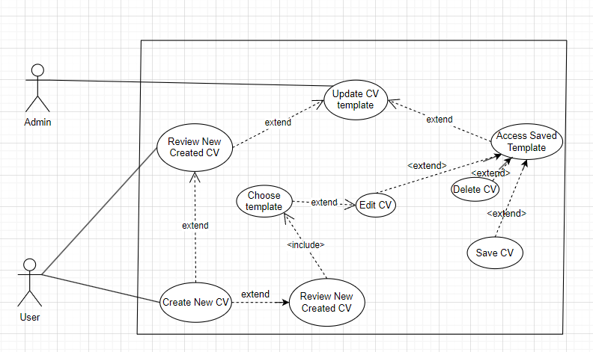*Figure 2.1.4: Use Case Create a CV and Access Profile*

###### Use case using a table format:

***Table 3: Use Case table for Create CV and Access profile***

|  |  |  |  |
| --- | --- | --- | --- |
| Use case name: | Create a CV and Access Storage | | |
| Created by: | Pham Dang Quang | Lastupdatedby: | Pham Dang Quang |

|  |  |  |  |
| --- | --- | --- | --- |
| Date created: | 13/10/2024 | Date last updated: | 15/10/2024 |
| Actors: | Users, System Module | | |
| Description: | Users can access the software to create and edit CVs | | |
| Preconditions: | * User access to the software * User needs to have Internet * User needs to choose the template | | |
| Postconditions: | * Always update the company template | | |
| Normal Flows: | 1. Users need to create an account. 2. The system module needs to create an account. 3. Users can save theirCV. 4. Users can review the CV. | | |
| AlternativFlows: | * 1. The account exists, fill in the Username and password then press Login.   2. The account doesn't exist ,press the Register button to create the account.   1.3 The Users can change their account  1.4 Users can edit the CV profiles.  1.6 Users can delete the CV. | | |
| Exceptions: |  | | |
| Note and issues: |  | | |

### Use Case Download

##### **User Story:** After the users finish saving their CV, they can download the CV in that page or in the CV stored

#### Use case diagram:

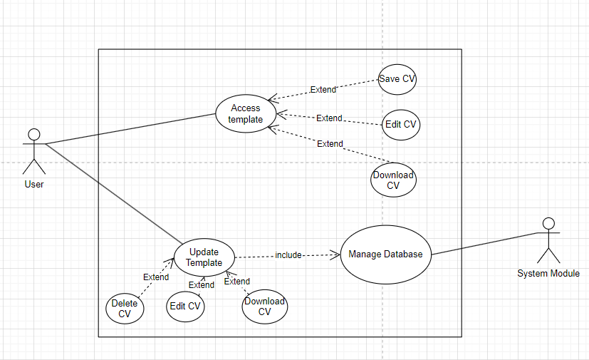

*Figure 2.1.5: Use Case Save , Download*

###### Use case using a table format:

***Table 4: Use case for Save, Download***

|  |  |  |  |
| --- | --- | --- | --- |
| Use case name: | Use Case Save, Download | | |
| Createdby: | Pham Dang Quang | Last updated by: | Pham Dang Quang |
| Date created: | 13/10/2024 | Date last updated: | 15/10/2024 |
| Actors: | Users, SystemModule | | |
| Description: | Users can access the software to Save and Download the CV. | | |
| Preconditions: | * User access to the software * User needs to have Internet | | |

|  |  |
| --- | --- |
|  | * User needs to choose the requirements document template |
| Postconditions: | * Always update the template |
| NormalFlows: | 1. Users review the new CV which is created by them. 2. The System Module needs to update the Database to Announce themessage. |
| AlternativeFlows: | * 1. Users can update their CVs and review them again.   2. Users pressthe download button.   1.3 Display the download successfully |
| Exceptions: |  |
| Noteandissues: |  |

1. **Functional Requirement**

* The system must authenticate user login credentials.
* The system must allow users to input CV information.
* The system must generate a new CV based on user input and a CV Template.
* The system must be able to store new CVs in the Database.
* The system must allow users to input keywords to search/filter criteria.
* The system must retrieve matching CVs from the CV Database based on users input.
* The system must allow users to access the CV template after searching to edit, save, and download.
* The system must allow users to save CVs to their UserStorage.
* The system must allow users to download CVs

1. **Non-Functional Requirement**

###### Usability Requirements:

* + The system should have an intuitive and user-friendly interface.
  + The system should provide clear instructions to the user.

###### Performance Requirements:

* + The system should be able to handle multiple simultaneous users without performance degradation.
  + The system should have a response time of less than 5 seconds for all operations.
  + The system should be available 99.9% of the time.

###### Space Requirements:

* + The system should efficiently manage storage to accommodate a large number of CVs.
  + The system should provide options for storage expansion.

###### Dependability Requirements:

* + The system should be reliable and produce consistent results.
  + The system should have a backup mechanism to prevent dataloss.

###### Security Requirements:

* + The system should encrypt sensitive user data.
  + The system should have measures to prevent unauthorized access.

###### Environmental Requirements:

* + The system should be compatible with various operating systems and browsers.
  + The system should be responsive and adaptable to various screensizes.

###### Operational Requirements:

* + The system should require minimal maintenance.
  + The system should provide easy trouble shooting and error handling.

###### Development Requirements:

* + The system should be developed using a modular approach for easy updates and modifications.

#### The system should follow coding standards and best practices for maintainability.

#### Design

#### System API Model

#### IMG_256

#### The client uses http through APIs and urls already linked in the front end to send Http posts, upload them to the server, from there the server returns the json files, get the json file and display it on the front end.

#### Entity-Relationship Diagram

#### 

#### Sequence Diagram

#### Diagram manages User Login-Register-Forgot Password:

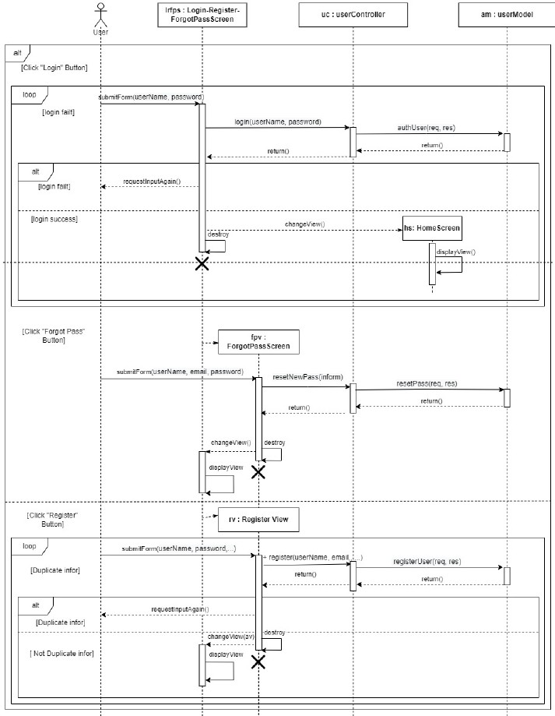

*Figure11:SequenceDiagramLogin/Register/Forgotpassword*

###### Diagram handles User Search CV Templates:

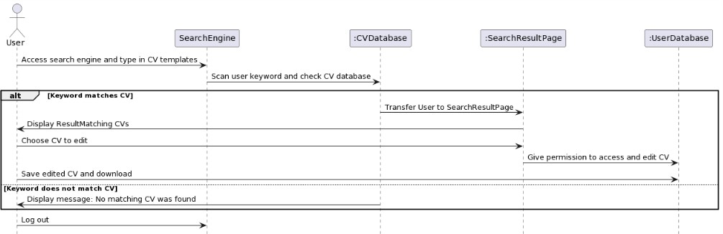

*Figure 12: Sequence Diagram Search CV Templates*

###### Diagram manages User to Create MyCV (both options Create a new CV and Already have CV):

*Figure13:SequenceDiagramCreate anewCVandAlreadyhaveaCV*

###### Diagram manages download

###### 

*Figure 14: Sequence Diagram download*

1. Class Diagram

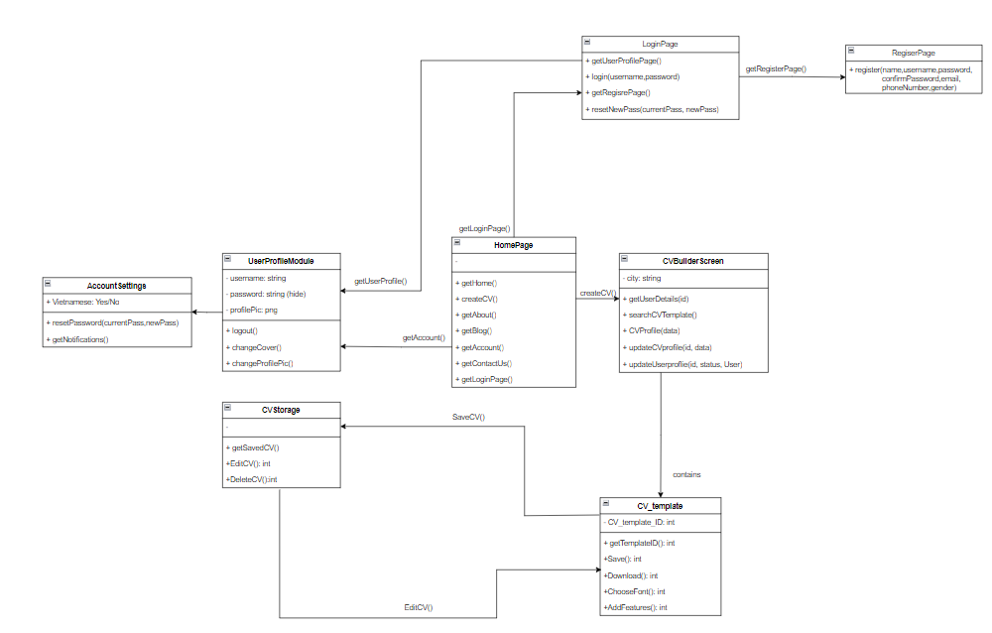

# IMPLEMENTATION TECHNOLOGIES

# Minimum Viable Product

# Login-Signup-Forgot Password

1. First, the users access the online CV builder website. They must Login into the system to create CV

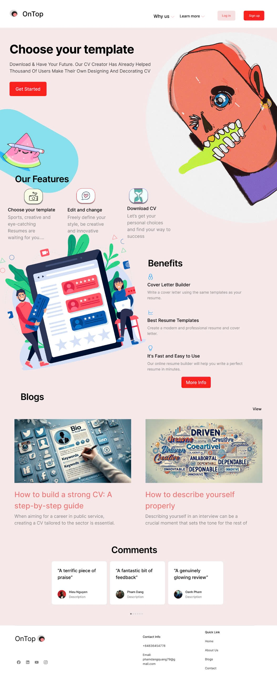

*Figure 3.1.1: Demo Homepage*

##### Secondly, If User choose to access their account, they push the Login

##### 

*Figure 3.1.2: Demo Login*

##### If the User does not have an account, They can SignUp

##### 

*Figure 3.1.3: Demo Register*

##### After successfully Register/Login, the User will be able to return to the Homepage and Create a CV. The system will give the User 2 options: Get Started or access the User Storage

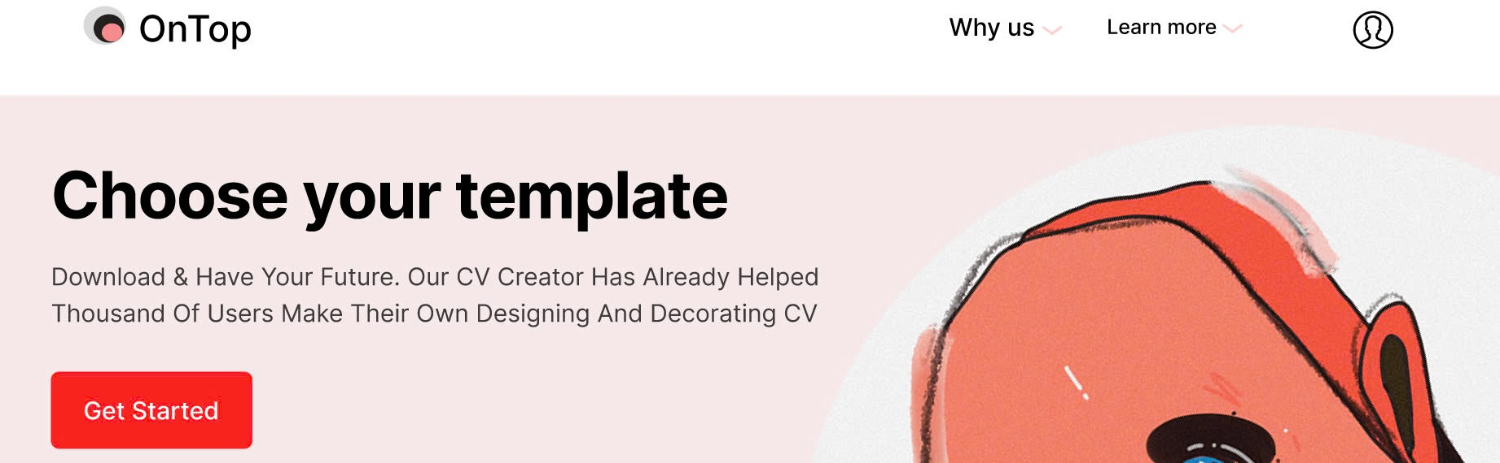

*Figure 3.1.4: Demo After Login in*

##### If the User forget their password, they can press Forgot password and theey will be navigated to this page:

##### 

*Figure 3.1.5: Demo Forgot Password*

1. The User also can change their password account when click the User Icon after Login

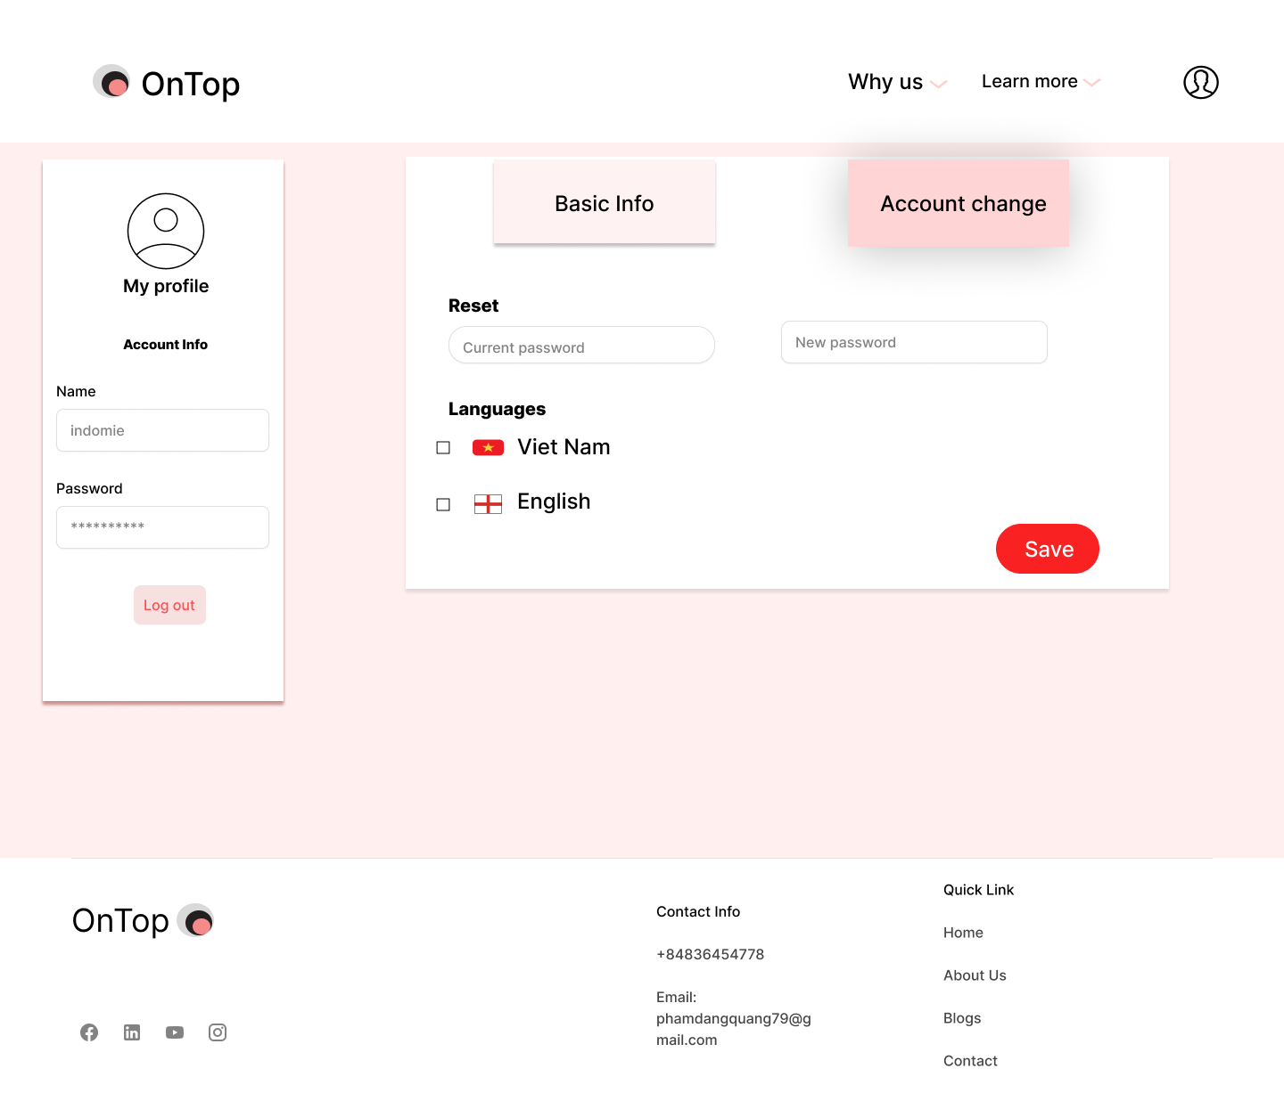

*Figure 3.1.6: Demo Change Account*

##### **Create CV**

##### When finishing logging in, the user now can create their CV based on template

##### 

*Figure 3.2.1: Demo After Login in*

1. After press the Get Started, the User will have some option on the CV

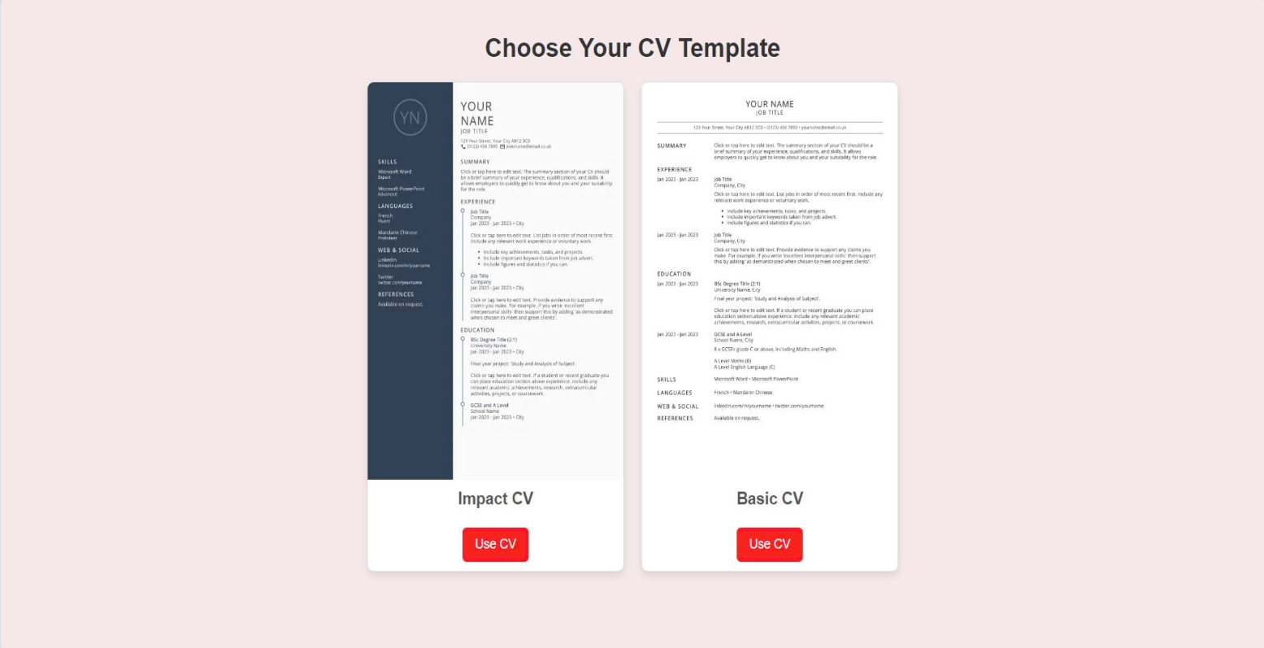

*Figure 3.2.2:Demo pick CV*

1. For example you pick the Impact CV, the page will allow you to edit it and save to your storage

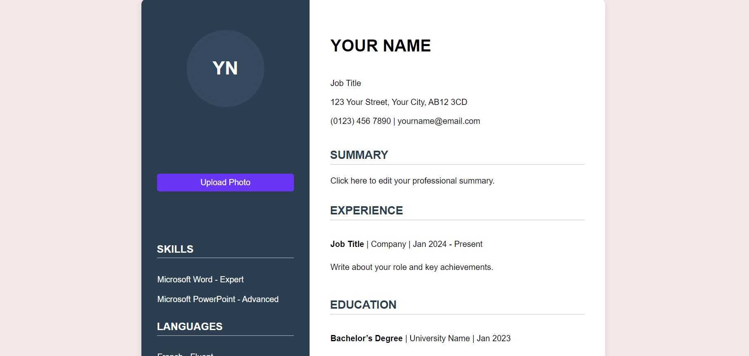

*Figure 3.2.3: CV page*

1. These are some options User can do on their CVs:

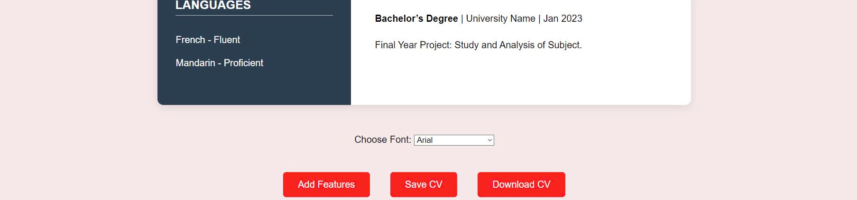

*Figure 3.3.4: Demo options CV*

1. If they want to add more section in your CV, they can press Add features:

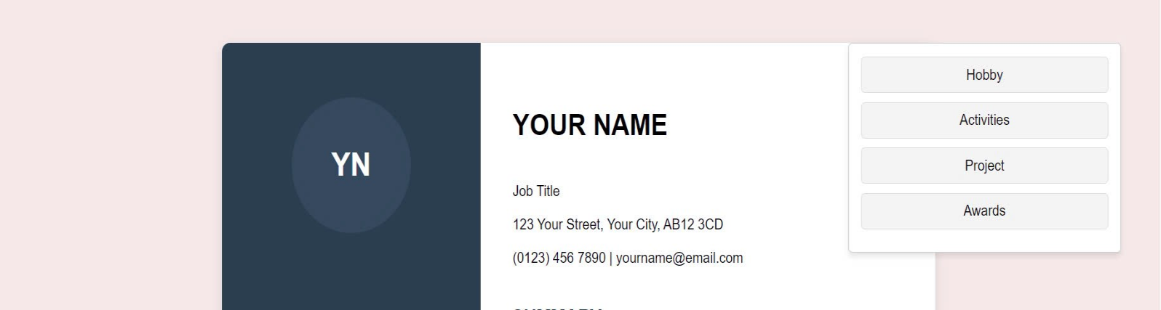

*Figure 3.2.5: Demo add featrures CV*

1. If they want to change the font, pick font in Choose font
2. **Save/Download CV**
3. When the User complete their CV, they have 2 options: Save or Download it



*Figure 3.3.1: Demo Save/Download*

1. If they press Save CV, the CV will be stored in the CV stored page which only can access when they have the account



*Figure 3.3.2: Demo CV stored*

1. In the CV stored, the user can choose to Edit or Delete the CV
2. If they press Edit, they will return to the CV page



*Figure 3.3.3:Demo Edit CV*



**4.Search CV**

1. There is a button that navigate user to CV stored

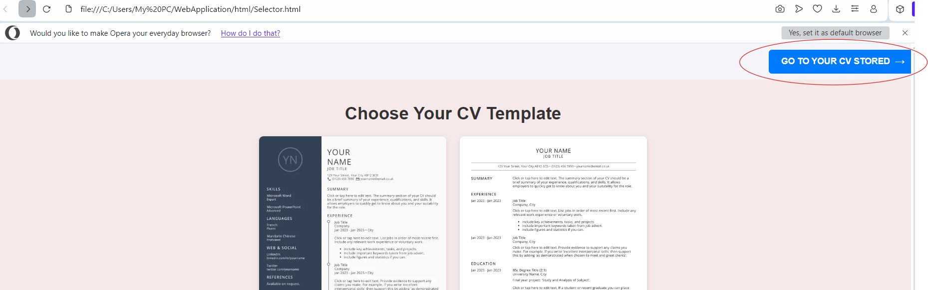

1. In the CV stored, Users can search their Saved CV in the search bar

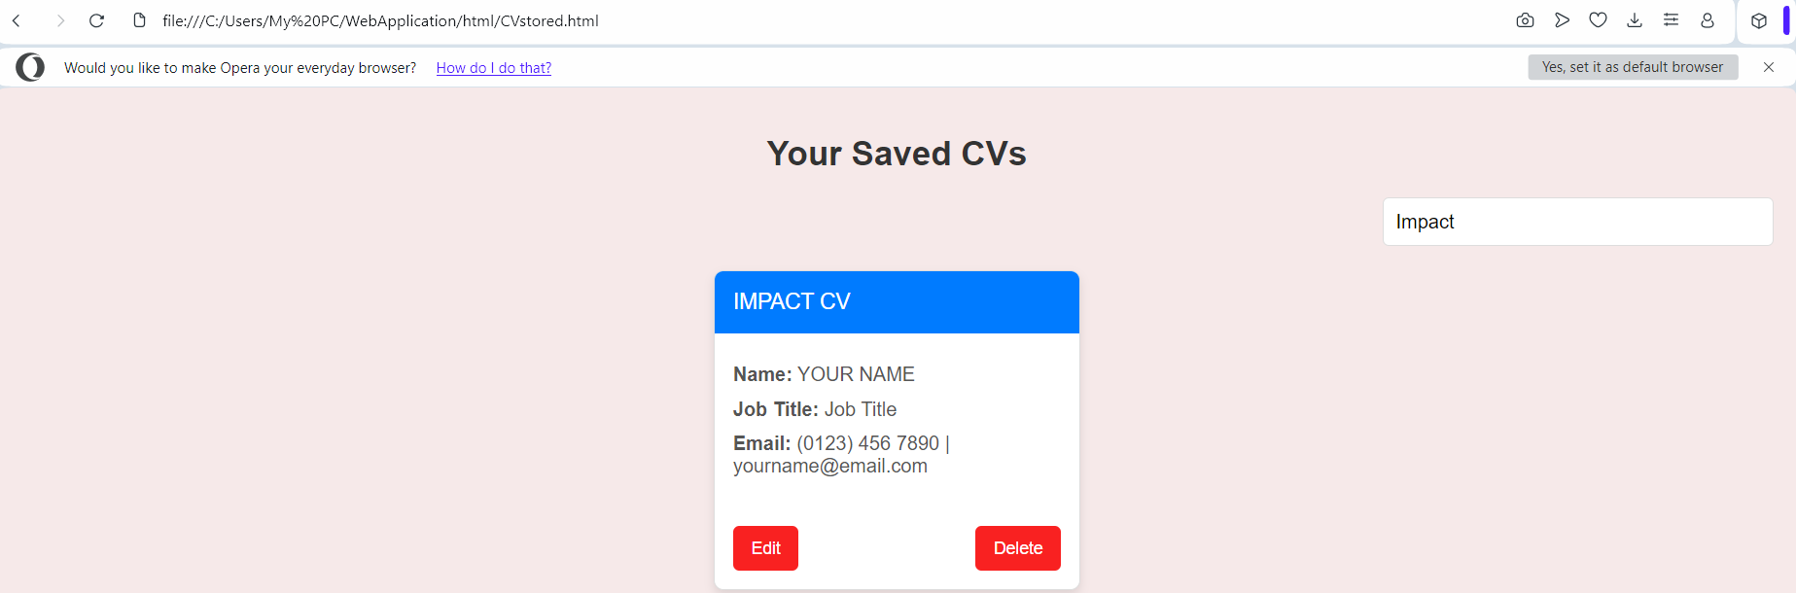

*Figure 3.3.4: Demo Search CV*

# DISCUSSION AND CONCLUSION

Through out this project,we have accomplished some achievements:

* We have created an online CV builder that allows users to create and download customized CVs in PDF format.
* Not only we have included templates, sections, fields, fonts, colors, previews, and downloads in the online CV builder software. But also we have incorporated animations into the website to make it look more professional.

However, Our software still has many limitations and features that need to be improved, such as:

* Our online CV builder only supports PDF format, which may not be compatible with some online platforms or systems. We can only improve this by adding other formats, such as DOCX, HTML, or TXT. This is due to the lack of time for us to cover all the features to the fullest.
* Our online CV builder only offers a few templates and options, which may not meet the preferences and requirement of some users. Furthermore, the templates are still basic, which may not meet many Users' needs in real life. To solve this, we need to add more templates and options, such as layouts, styles, icons, or images in the future.
* Our online CV builder only works online, which may not be accessible or convenient for some users if their connection is interrupted while they are editing.

We intend to expand our CV builder's functionality in the future by adding more customization choices and the capacity to save and download resumes in other formats. Based on customer input, we also hope to enhance the user interface. To turn this project into a business website in the future, we will also include payment facilities.

In summary, we have developed an online CV Builder that enables users to generate and save customized resumes in PDF format. From the project strategy to system analysis and design and execution, we have followed software engineering principles and practices. In the Implementation section, we also demonstrated the features and capabilities of our online CV maker.

# References

GitHub:

Link: